SQL- Subqueries

& Nested SELECTs

Dataset: Online Retail Store

Tables Structure

🟦 customers
CREATE TABLE customers (
customer_id INT PRIMARY KEY,
customer_name VARCHAR(50),
city VARCHAR(50)
);

🟦 categories

CREATE TABLE categories (
category_id INT PRIMARY KEY,
category_name VARCHAR(50)
);

🟦 products

CREATE TABLE products (
product_id INT PRIMARY KEY,
product_name VARCHAR(50),
category_id INT,
price DECIMAL(10,2),
FOREIGN KEY (category_id) REFERENCES categories(category_id)
);

🟦 orders

CREATE TABLE orders (
order_id INT PRIMARY KEY,
customer_id INT,
order_date DATE,
FOREIGN KEY (customer_id) REFERENCES customers(customer_id)
);
🟦 order_items

CREATE TABLE order_items (
order_item_id INT PRIMARY KEY,
order_id INT,
product_id INT,
quantity INT,
FOREIGN KEY (order_id) REFERENCES orders(order_id),
FOREIGN KEY (product_id) REFERENCES products(product_id)
);

2️⃣ Data

Customers

INSERT INTO customers VALUES
(1,'Amit','Delhi'),
(2,'Neha','Mumbai'),
(3,'Rahul','Bangalore'),
(4,'Pooja','Delhi');

categories
INSERT INTO categories VALUES
(1,'Electronics'),
(2,'Clothing'),
(3,'Home');

Products

INSERT INTO products VALUES
(1,'Laptop',1,60000),
(2,'Mobile',1,30000),
(3,'Headphones',1,2000),
(4,'T-Shirt',2,800),
(5,'Jeans',2,2000),
(6,'Mixer',3,4000);
Orders

INSERT INTO orders VALUES
(101,1,'2024-01-10'),
(102,2,'2024-01-12'),
(103,3,'2024-01-15'),
(104,1,'2024-01-20'),
(105,4,'2024-01-22');

Order_items
INSERT INTO order_items VALUES
(1,101,1,1),
(2,101,3,2),
(3,102,2,1),
(4,102,4,3),
(5,103,5,2),
(6,104,1,1),
(7,104,6,1),
(8,105,3,4);

Question

Q1. Find products that are priced higher than the average product price.

Thinking Approach
- First find average price
- Compare each product price with that value

-- write your code
select *
from products
where price > (
select avg(price)
from products
);
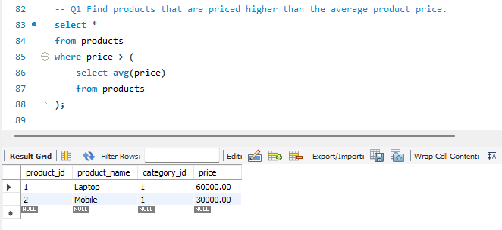
Q2. Find customers who have placed at least one order.

Thinking Approach
- Get list of customer_ids from orders
- Match them with customers table
-- write your code
select distinct(customer_name)
from customers c join orders o on c.customer_id = o.customer_id;
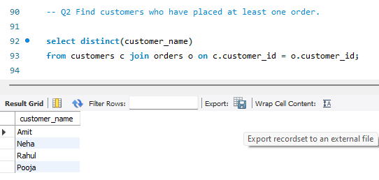
Q3. Find products that are the most expensive within their own category.
-- write your code
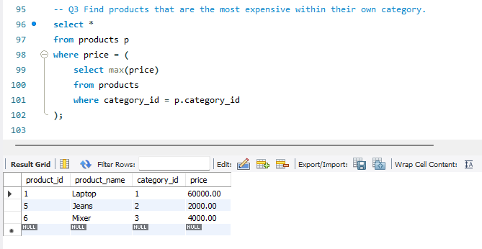

Q4. Find customers who have ordered Electronics products.

Thinking Approach
- We don’t care how many
- Just check if it exists
-- write your code
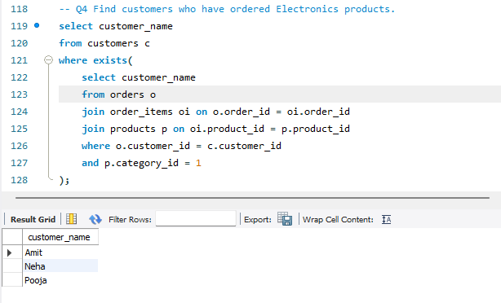

Optional questions

- Products cheaper than average price

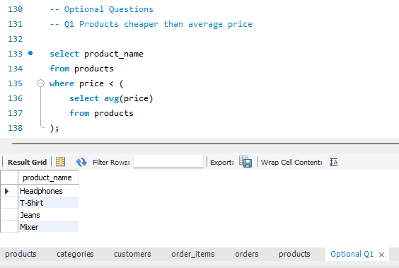
- Customers from cities that have orders

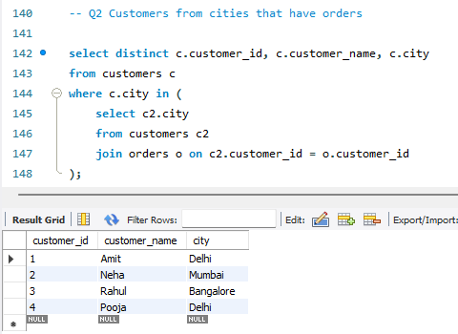
- Cheapest product in each category

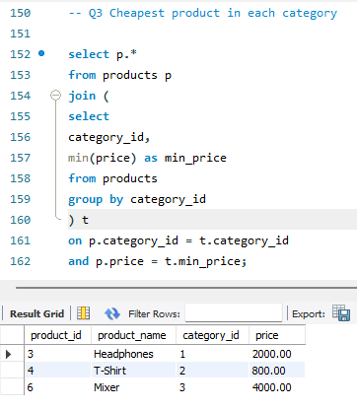

- Customers who ordered Clothing

